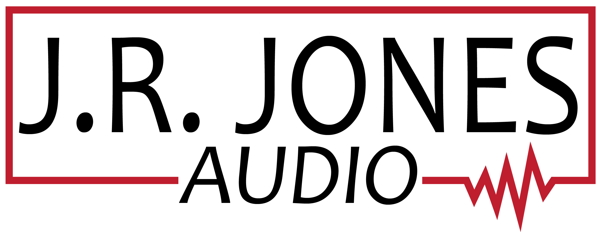
636-221-2116

Contract Agreement

J.R. Jones Audio and ______________________ enter into this contract agreement for ______________________, (Occasion) on ________________. (date)

Address and Location of Event ___________________________________________.
Client’s Phone Number ________________________.

J.R. Jones Audio agrees to provide music entertainment
from:__________ until ____________, (time) on the date listed above.

A $250.00 non-refundable deposit (extenuating circumstances will be able to be rescheduled, if date is available) is required to reserve J.R. Jones Audio for the date/time listed above.
Date deposit paid __________ by the means of _______________. (payment method)

- Dinner and drinks are to be provided for D.J. on date listed above.
- The balance due must be paid in full 14 days prior to the event.
- In the unlikely event of an emergency, it shall be the duty of J.R. Jones Audio to attempt to arrange a replacement D.J. as required to fulfill this contract agreement.

By signing below, client acknowledges: I have read, understand, and agree to all of the terms in this contract.

_______________________________________ ___________________________________________
Client’s signature & today’s date Owner’s signature, J.R. Jones

Thank you for choosing J.R. Jones Audio!

